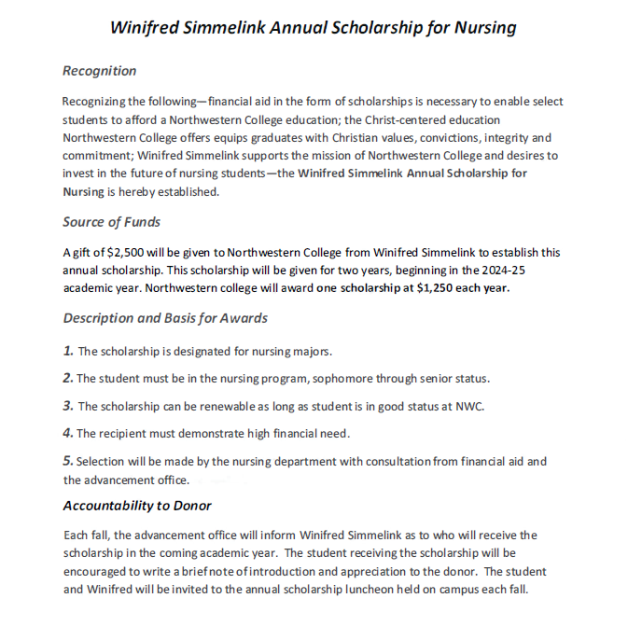

**Winifred Simmelink Annual Scholarship for Nursing**

Please complete the following, print, and submit to the Department of Nursing

|  |  |  |  |
| --- | --- | --- | --- |
| **Name** | **Current Year in**  **BSN program** | **Current CGPA** | **Renewal (Y or N)** |
|  |  |  |  |

**Complete the following essay question:**

Reflecting on healthcare practice today and the increasing use of technology, explain how you hope to demonstrate Christ-like caring to those you serve.